Morning Offer of the Brides of the Most Blessed Trinity
Holy Blessed Trinity, I offer you all my prayers, works, joys, and sufferings of this day.
No matter what little thing I do, I offer it to you in reparation: for holy priests, for the conversion of priests, for more priests, for the return of many priests who have left the priesthood, and for the priests still in purgatory, especially those most in need.
I offer myself this day (optional: and hereafter until my death) as an offering for holy priests, in union with the Suffering, Death, and Resurrection of Jesus, and in union with the Sacred Body and Blood of Jesus consecrated daily on all the altars of the world by Your holy priests.
I make this offering freely, trusting that you will take care of all my needs, both spiritual and temporal, for the state in life to which you have called me.
I make this offering through the Immaculate Hands and Heart of the Blessed Virgin Mary, Mother of Divine Love, that She might take this imperfect prayer and present it to Her Son, that through His Sacred Heart He might perfect it, and present it to Our Father by the Power of the Holy Spirit, through Jesus Christ Our Lord. Amen.

A Daily Prayer for Priests
Jesus Good Shepherd, Great High Priest, today I life to you in prayer all of our priests. You left us Yourself in the person of the priest. Mold them into what You want them to be. Let them be You to each person they meet. May they fill all the needs of those who turn to them today. Send someone to lift their spirit and to be Jesus to them when others knock them down, to encourage them when their hope is gone. Give them all the strength and courage they need to persevere in holiness when under trial or just worn out from saving souls. Please bless us with many more holy priests. Teach us to love and appreciate our priests and to see you in them.
I consecrate all priests to the Immaculate Hands and Heart of the Blessed Virgin Mary, Our Mother of Divine Love, Patroness of Priests. I thank You for their priesthood. Keep them close to You. Please enfold and protect them in Your Mantle of Divine Love.
My Lord Jesus I trust in You! Amen

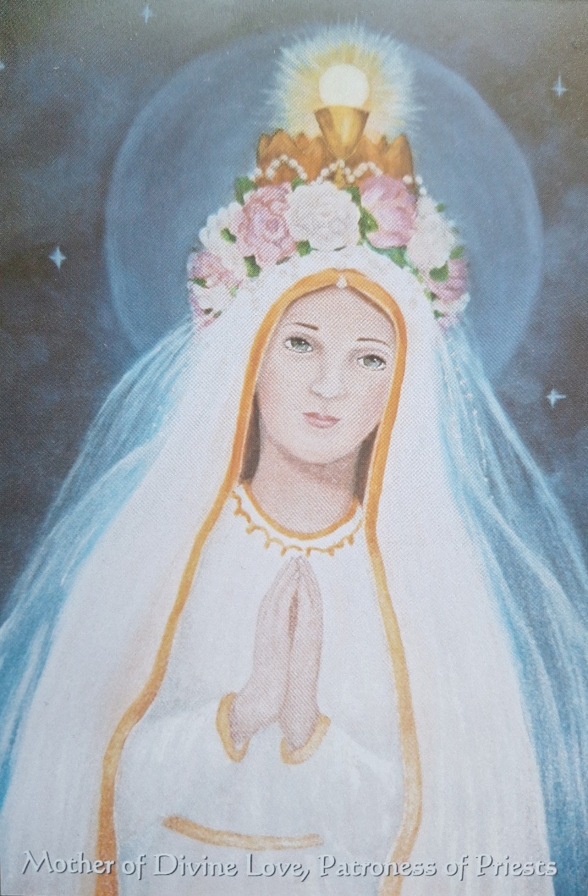
Chaplet of Divine Love for Priests
The Chaplet is to have a Crucifix, one bead, then a medal of Our Lady and the Trinity. Next are 33 beads that represent the 33 years Jesus spent on earth to join at the medal. [This can also be prayed on the first three decades of a Rosary]
-Begin with the Sign of the Cross.
-Pray the Creed on the Crucifix.
-Pray the “Our Father” on the first bead.
-Pray the “Hail Mary” on the medal.
-Pray “O Jesus, Son of the Living God, have mercy on us and on all our Priests” (or you may name a priest) on the 33 beads.
-On the medal Pray: “O Sacrament Most Holy, O Sacrament Divine, all praise and all thanksgiving be every moment Thine. Blessed be the Holy and Immaculate Conception of the Most Blessed Virgin Mary, Mother of God, Mary Most Holy. Mary, Queen of Divine Love, Patroness of Priests, pray for us. God Our Father, please send us Holy Priests, all for the Sacred and Eucharistic Heart of Jesus, all for the Sorrowful and Immaculate Heart of Mary, in union with St. Joseph. Ave, Ave, Ave Maria. Ave, Ave, Ave Maria.”
-Pray the “Glory Be” on the single bead.
-Pray the “St. Michael Prayer” on the Crucifix.

